# **TAKEAWAY FOR SESSION 1, MODULE 5:**

Here is the text from session 1, Learning Block 1:

In this session, we are going to focus on the key skills essential for successful inclusive support within the role of the SNA. We will also reflect on a personal Skills Profile which will result in insight into our current Skills and Qualities. Our current Skills and Knowledge come from Prior Learning and Experience combined with how we view our current situation and our willingness to engage in continuous learning. Personal Development is very important because of our human nature. We re-visit Maslow’s Hierarchy of Needs in order to try to better understand why we need to engage in Personal Development. The secret lies in the tip of the pyramid – **Self Actualisation – see graphic below:**

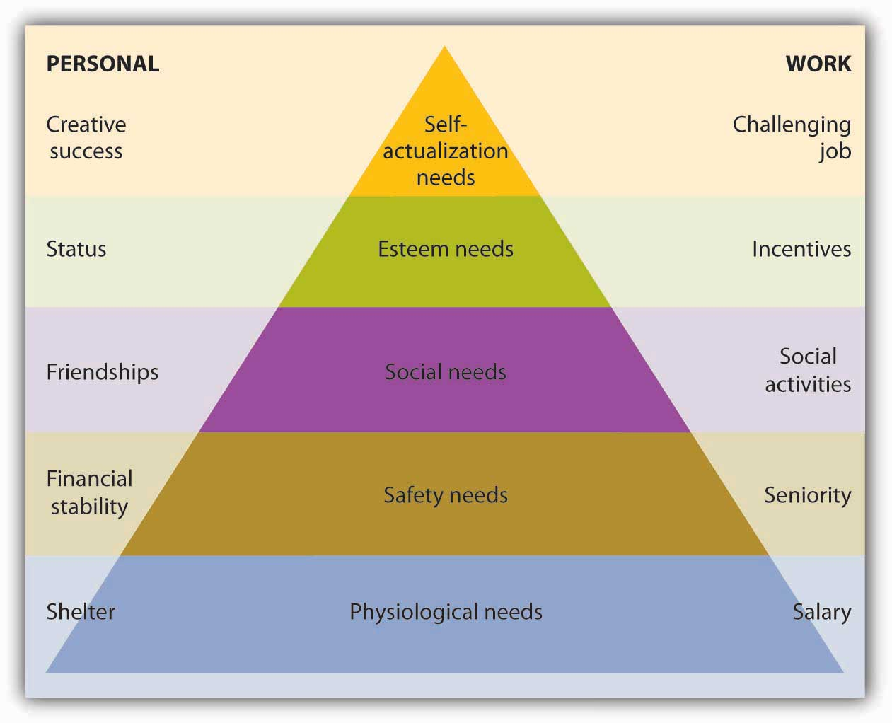

In the above chart, you can see that the needs are attributed within two categories, personal and work. In order to achieve total self - actualisation, we need to successfully merge these two. However, in order to reach the tip of the pyramid, we also need to climb through each of the levels successfully in order to move forward to the next level. The foundation must be solid by achieving each level successfully.

**Definition of Self Actualisation:**

**Self-actualisation** refers to the desire that everybody has to become ‘*everything that they are capable of becoming.’* This means reaching our full potential as a human being. Maslow (1970) told us that the path to self-actualisation involves being in touch with your feelings, experiencing life fully and with total concentration.

In order to achieve successful personal development, we must *make a plan*. This plan takes us through a process of skills-development. Here, we will examine skills and the various categories of skills and qualities needed to develop personally and reach our self-actualisation goal.

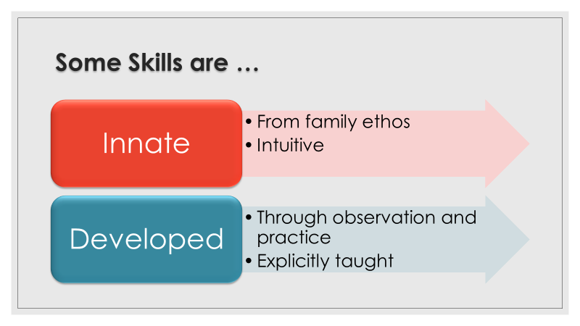

Some **Skills** are innate; in other words, we develop these from a very young age by **being part of a secure and consistent environment where there is encouragement to experiment and explore.**

**Other Skills are Developed through Observing significant adults and peers while engaged in:**

* modelling consistently positive actions
* using respectful verbal communication
* solving simple problems
* using equipment and utensils
* promoting an atmosphere of enquiry and exploration
* completing certain systematic processes
* experiencing successful outcomes in actions and activities

**and through practice and explicit teaching.**

***The more significant the skill is to everyday application within our lives, the more likely it is that we will want to develop that skill. This is an important message to remember in terms of intrinsic motivation for children to engage in learning.***

**QUALITIES,** on the other hand, are subtle and sometimes confused with Skills. Qualities are more abstract and integrated within Personality. In order to better explain the difference between Skills and Qualities, here is a short video which shows this difference more clearly:

<https://www.youtube.com/watch?v=lV-EtTbGK1c>

**Skills can be categorised in Two Ways:**

**Hard Skills** are matched to a particular outcome and are specialised in terms of the process involved e.g. driving a car. Hard Skills are those we learn in order to live independently and contribute to productivity in the home and workplace. Woodwork, painting, writing, singing, public-speaking, using technical equipment and machinery are ‘hard skills’.

**Soft Skills** are more abstract and central to communication and the development of relationships. We can divide ‘Soft’ skills into **Intrapersonal** Skills and **Interpersonal** Skills e.g. listening, recognising emotions**.** The term **Intrapersonal skills** refers to how well we know ourselves; while the term **interpersonal skills** refers to our ability to interact with others. If we have some difficulty with Intrapersonal skills, then we will have more significant difficulties with Interpersonal skills.

Soft skills are somewhat subtle and are extremely important for anyone who works in group settings such as school environments. These soft skills allow for harmonious relationships and effective teamwork and productivity. Soft skills contribute positively to a pleasant working environment. Showing empathy, being helpful, friendly, cooperative, flexible, supportive and intuitive are ‘soft skills’ and represent our ‘people skills’. We can cultivate our soft skills through life-experience and through activating our emotional intelligence. These skills allow us to judge people, to predict how people may react, to respond to questions and problems, to build trusting relationships and to contribute to a good working dynamic in any setting. For the SNA, the relationships involved are complex and varied. People skills are essential in order to support pupils and work as part of a multidisciplinary team.

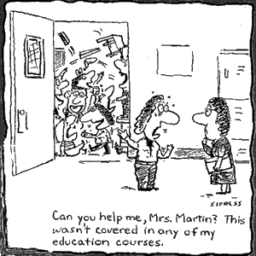

**The Special Needs Assistant – extensive range of skills needed:**

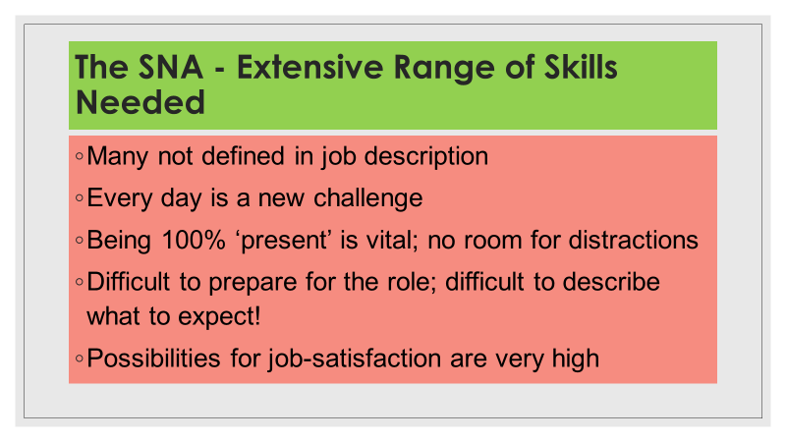

You will not find reference to all of these required skills in the job-description. Every day presents a new challenge within the inclusive classroom setting. Being 100% ‘present’ is vital for success; there is no room for distractions like family issues or social problems outside the school environment. It is difficult to prepare for the role and it is difficult to describe what to expect when you enter the classroom. There is so much variance among the many school-contexts. Despite this complexity, the possibilities for job-satisfaction are very high. It is interesting at this point to look again at the official job description as presented in the official DES Circular for the role of the SNA:

Insert Ref/link: (DES 0030/2014)

SNA support is provided specifically to assist recognised primary, post primary and special schools to cater for the care needs of pupils with disabilities in an educational context, where the nature of these care needs have been outlined in professional reports as being so significant that a pupil will require adult assistance in order to be able to attend school and to participate in education. (p.4)

Applications for SNA support will be considered under this scheme where medical or other relevant professional reports set out that a pupil has significant care needs arising from: (i) a significant medical need, or (ii) a significant impairment of physical or sensory function. (p.4)

Examples of the **primary care needs** which would be considered significant – and which might require SNA support are:

* Assistance with feeding: where a child with special needs requires adult assistance and where the extent of assistance required would overly disrupt normal teaching time
* Administration of medicine: where a child requires adult assistance to administer medicine and where the extent of assistance required would overly disrupt normal teaching time
* Assistance with toileting and general hygiene: (including catheterisation) where a child with special needs cannot independently self-toilet, and until such time as they are able to do so
* Assistance with mobility and orientation: on an ongoing basis including assisting a 6 child or children to access the school, the classroom, with accessing school transport (where provided, school Bus Escorts should, in the first instance, assist a child to access school transport), or helping a child to avoid hazards in or surrounding the school. (Every effort must be made by the school to provide opportunities for independence e.g. the removal of hazards.)
* Assisting teachers to provide supervision in the class, playground and school grounds: at recreation, assembly, and dispersal times including assistance with arriving and departing from school for pupils with special needs where the school has made a robust case that existing teaching resources cannot facilitate such supervision
* Non-nursing care needs associated with specific medical conditions: such as frequent epileptic seizures or for pupils who have fragile health.
* Care needs requiring frequent interventions including withdrawal of a pupil from a classroom when essential: This may be for safety or personal care reasons, or where a child may be required to leave the class for medical reasons or due to distress on a frequent basis.
* Assistance with moving and lifting of children, operation of hoists and equipment.
* Assistance with severe communication difficulties including enabling curriculum access for pupils with physical disabilities or sensory needs (See also section 9) and those with significant, and identified social and emotional difficulties. Under the direction of the teacher, this might include assistance with assistive technology equipment, typing or handwriting, supporting transition, assisting with supervision at recreation, dispersal times etc. The tasks noted above are the primary care support tasks for which access to SNA support will normally be provided.

The following is a list of Secondary Care Needs, as described by the Circular:

* Preparation and tidying of workspaces and classrooms or assisting a child who is not physically able to perform such tasks to prepare and tidy a workspace, to present materials, to display work, or to transition from one lesson activity to another. To assist with cleaning of materials.
* Assistance with the development of Personal Pupil Plans for children with special educational needs, with a particular focus on developing a care plan to meet the care needs of the pupil concerned and the review of such plans.
* Assist teachers and/or Principal in maintaining a journal or care monitoring system for pupils including details of attendance and care needs. Assist in preparation of school files and materials relating to care and assistance required in class by students with special needs.
* Planning for activities and classes where there may be additional care requirements associated with particular activities, liaising with class teachers and other teachers such as the resource teacher and school principal, attending meetings with parents, SENO, NEPS Psychologists, or school staff meetings with the agreement and guidance of class teacher/principal
* Assistance with enabling a pupil to access therapy or psycho-educational programmes such as anger management or social skills classes, under the direction of qualified personnel, including class teachers or support teachers.
* Assistance to attend or participate in out of school activities: walks, or visits, where such assistance cannot be provided by teaching staff.

The ultimate goal within the role of the Special Needs Assistant is to enable the independence of the student/s, so that they can achieve to their optimum potential in education and life. Here are some of the key skills which are relevant to the role:

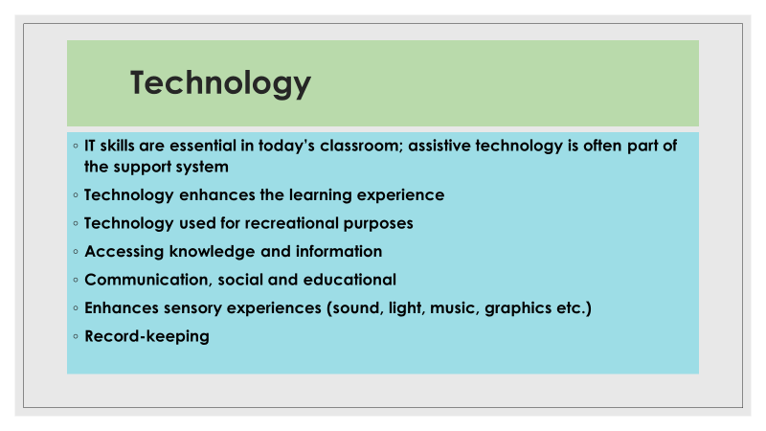

Technology has changed our lives and in particular the lives of many of our most vulnerable children and young people. I.T. is part of teaching and learning, while assistive technology enhances the mobility and communication skills of many. There is no doubt that technology enhances learning by making it more attractive-looking. Technology has become a big part of recreational activity for children and young people globally. Small mobile devices have become an integrated part of the person for many and this raises its own set of questions. Technology allows for ease of access to information and knowledge. It also allows us to communicate for social and educational reasons. Technology can greatly enhance or regulate sensory experiences for many, especially those with Autism. Graphic displays make our world more colourful. Technology is also very useful for record-keeping. These are just many of the ways in which we use technology within the school setting. There are few limitations to technology in today’s world. As part of an integral support system in schools, SNAs need technological skills.

**Communication has been extensively dealt with in Module 2.** However, it is important to recognise the importance of good skills of communication for the role of the successful SNA. Communication is a pivotal skill for working with both adults and children. Clear unambiguous communication is essential in the school environment. Consistent use of language helps to build children’s vocabulary and language skills, while creating a secure atmosphere.

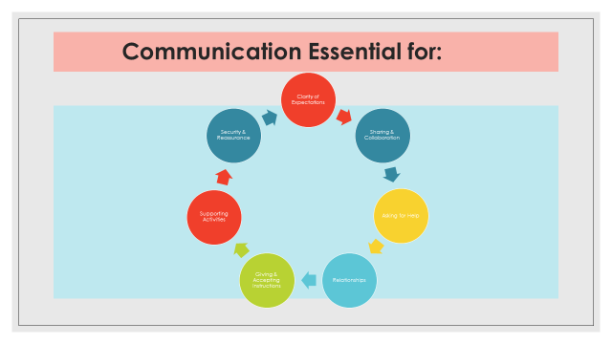

**Sports**

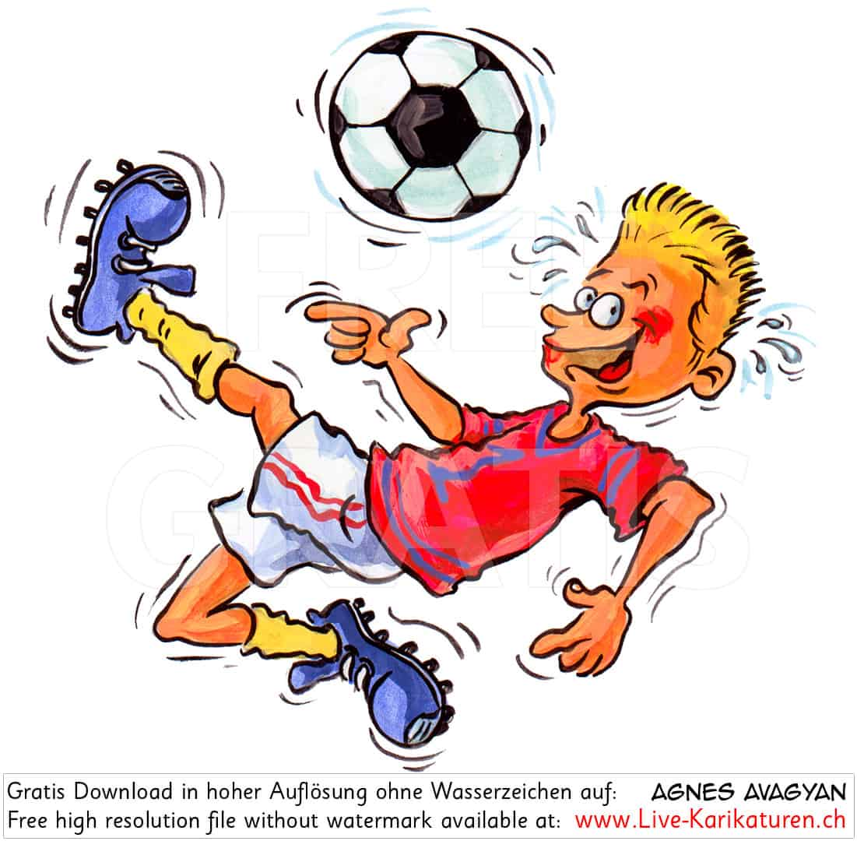

Most people have some interest in sports, while many excel in certain sports. Sharing this skill and talent fits neatly into the role of the SNA. A love for a particular sport generates an enthusiasm which can easily be transmitted to those young people we support. Alternatively, we may need to develop an interest in a sport in which they are interested. Team sports dominate the Irish culture, with a great array of team sports available.

Board games like Chess, Draughts and Monopoly are games of particular skill and allow for cooperative learning, accepting winning and losing, social interaction and strategic decision-making. For students who are not ready for team-sports, board games can provide an opportunity to excel and succeed in indoor games. Individual sports like athletics, swimming, cycling or racquet sports fit easily into a school environment., while providing for the development of coordinated movement, hand-eye coordination etc. Racquet-sports, such as Badminton or Table Tennis facilitate hand-eye-coordination, reflex movement and spatial awareness. These activities can be easily accommodated in the average school environment and provide alternative activity for inclement weather.

Many SNAs have a high level of competence in certain sports and this needs to be shared within the role. It is important to list these on a CV when applying for a job as a Special Needs Assistant.

Many adults in school settings have experience of and expertise in a range of outdoor pursuits. Enthusiasm for these activities can be successfully transferred when adults share this expertise. These activities can include:

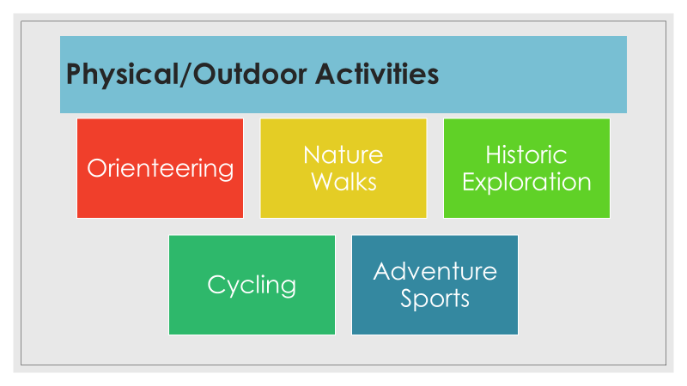

**Creative Skills**

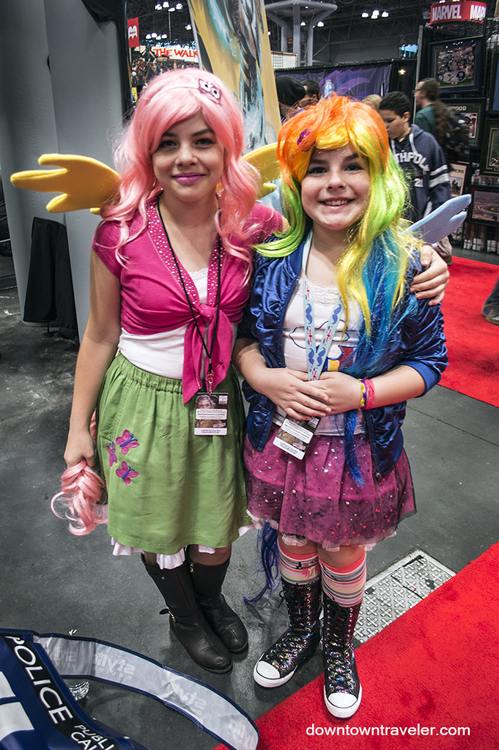

**Creative skills are much sought-after within the role of the SNA.** Many Special Needs Assistants are extremely creative and have backgrounds and talent in artistic pursuits. These skills are especially useful as a communication tool and a way to engage students who wish to relax, express themselves in different ways and experience new media.

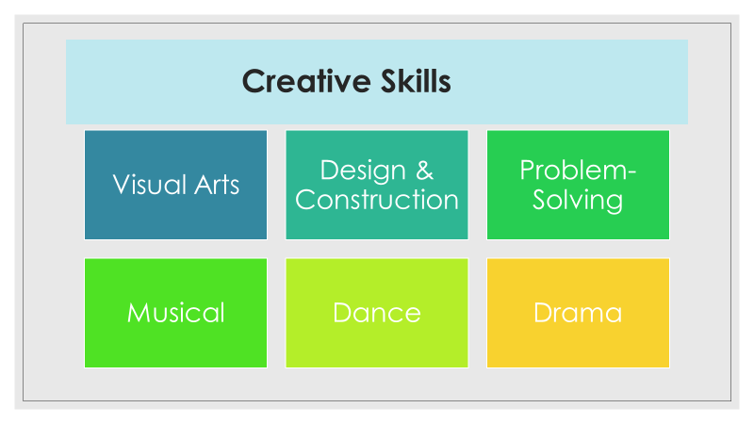

Being creative allows us to facilitate expression of emotions and ideas, in children and young adults, through creative arts activity. Project work, design and construction provide exciting opportunities for collaborative activity while promoting social interaction within a group. These activities also allow for facilitation of success for many who may struggle with more academic-type activities. Listening to music and music performance is accessible to everyone, with careful planning; while dance and drama have become a very important part of life in many school settings. The contribution of a creative SNA to a classroom is invaluable and allows for special relationships to develop within a classroom environment, while engaged in planned creative activity. Relaxation and Mindfulness through art activity has become a part of daily school life for many, in a world where we see increasing numbers of children suffering from mental health issues like depression and anxiety.

**Vocational & Domestic Skills:**

With the main goal of the role of the SNA as promoting independence in the students they support, the deployment of Domestic and Everyday Living Skills are significant.

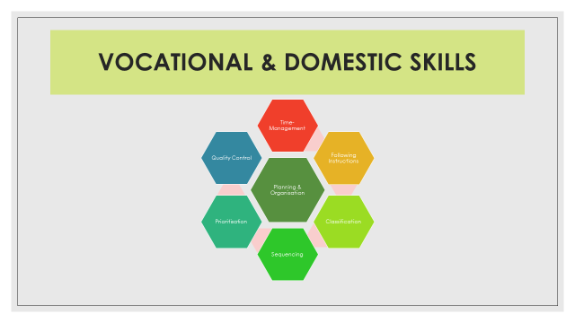

The skills of:

* Time management
* Following Instructions
* Classification
* Sequencing
* Prioritisation
* Quality Control

…feed into Planning and Organisation.

While specialist skills needed for personal care and daily living also include the use of domestic appliances, simple cooking and food-preparation, care of clothing, purchasing personal items, managing transport timetables, simple first-aid, personal hygiene and health and safety among a long list of possible skills needed.

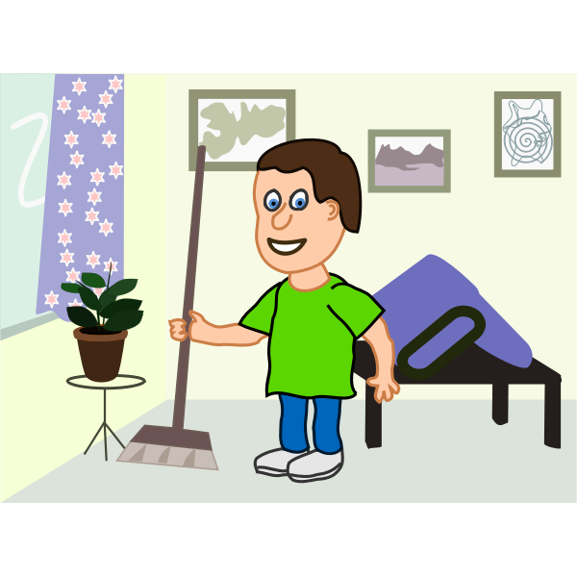

**Many children and young people with additional needs struggle with the most basic skills which allow them to navigate everyday activities – dressing, feeding, using domestic appliances etc.** Adaptive Living skills can be incorporated into daily school activities within the school setting.

**Here, we see a list of some of the core skills needed for Successful Inclusive Support:**

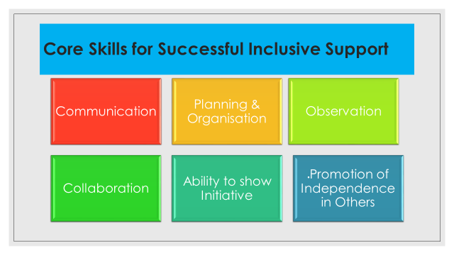

**The Communication Process:**

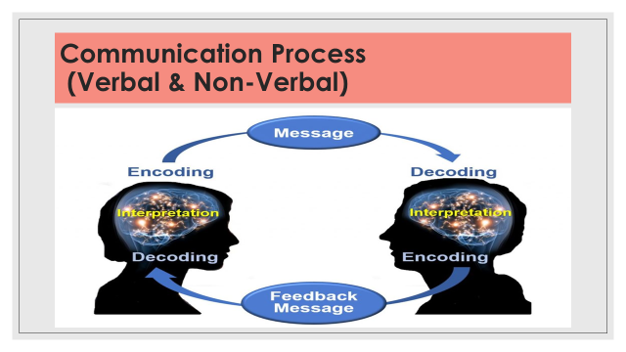

**Core Skills of Communication:**

**Non-Verbal Communication skills are very powerful personal tools and refinement of these skills is most useful as a Special Needs Assistant.** Non-Verbal communication skills can convey messages very efficiently and are very powerful and facilitate a wide-ranging communication for many students with additional needs. The skill of positioning is a very powerful message conveyed by a practicing SNA. Some students dislike having a supporting adult in close proximity and SNAs must recognize and respect this preference. The use of ICT and Assistive Technology for communication has opened up new world for many students with additional needs (as described by Ann Jackson in Module 1). For the SNA, becoming familiar with such technology is essential in order to maximise the benefits of this method of communication. Many students rely on visual cues for direction and these can be created using digital photography and lamination (SNAs working in units for Autism will be very familiar with this type of communication system).

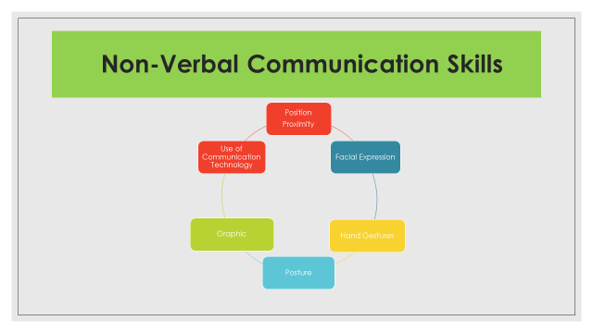

The core skills of communication involve extensive development and support for many students:

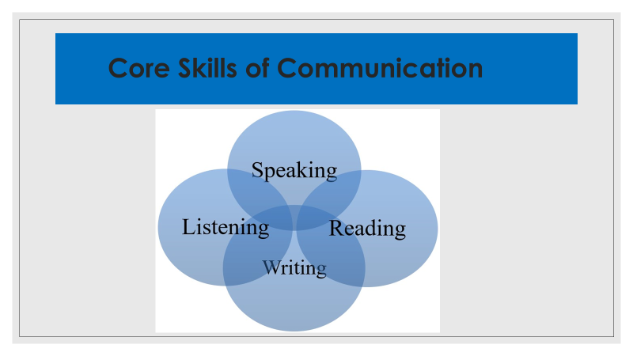

**Planning and Organisation, a look at the necessary skills involved:**

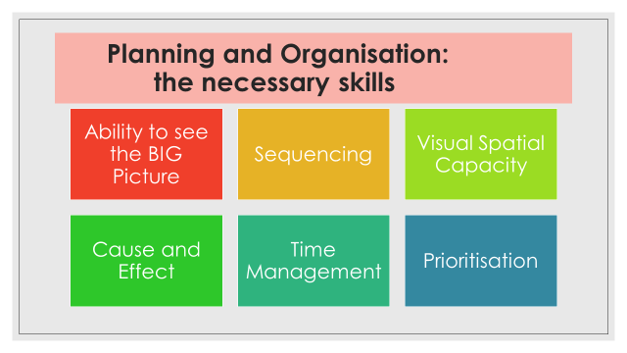

**The skills of Observation:**

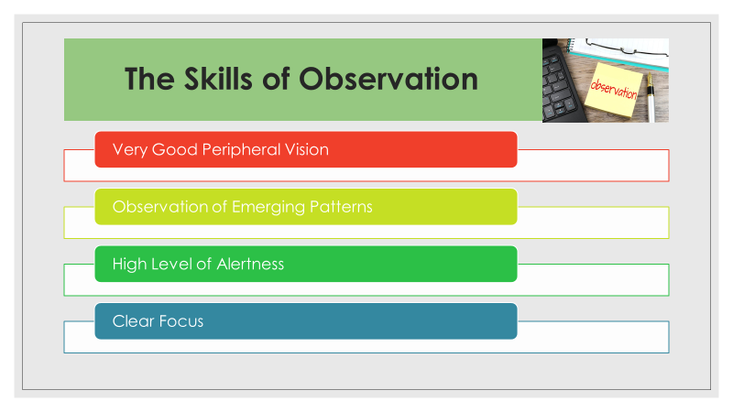

**Collaboration**

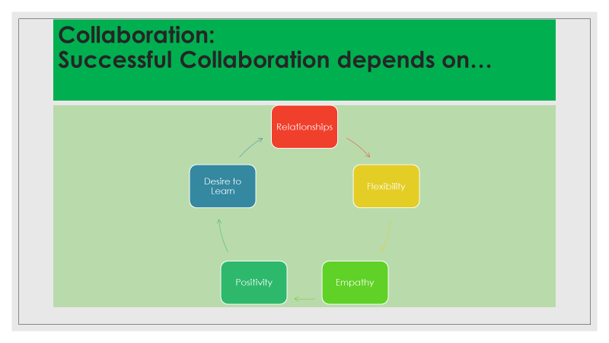

**Successful collaboration depends on a combination of skills and qualities:**

* **Relationships**
* **Flexibility**
* **Empathy**
* **Positivity**
* **Desire to learn**

**Ability to show INITIATIVE:**



**Requires Positive Energy, Enthusiasm and a Desire to Help. When we model these attributes, children learn from our actions. We make a difference!**

**The Promotion of Independence in others, especially vulnerable children and young people, takes careful planning and execution. Based on the theories of Vygotsky (1962, 1978), we can use his *More Knowledgeable Other* theory (MKO), *Scaffolding* or Working within the *Zone of Proximal Development* (ZPD).**

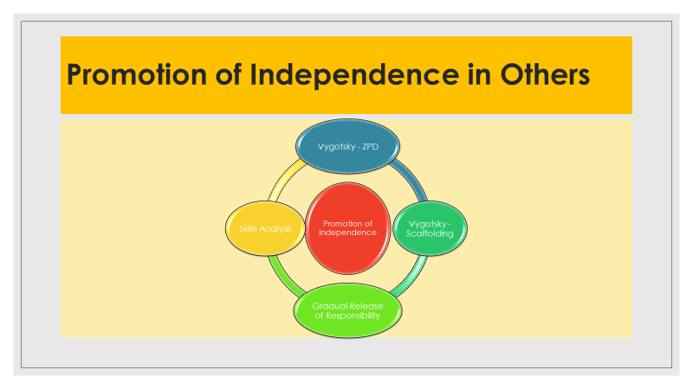

**Now, click into the following link to watch a short video about Vygotsky’s theories, as described here.**

[**https://youtu.be/4AoLk5nbliM**](https://youtu.be/4AoLk5nbliM)

**The Gradual Release of Responsibility Model is also based on Vygotskian theory, among others. Here it is described in six words:**

**Show me, help me, let me.**

The gradual release of responsibility model of instruction suggests that cognitive work should shift slowly and intentionally from teacher modelling, to joint responsibility between teachers and students, to independent practice and application by the learner (Pearson & Gallagher, 1983). This model provides a structure for teachers to move from assuming “all the responsibility for performing a task . . . to a situation in which the students assume all of the responsibility” (Duke & Pearson, 2004, p. 211). The model is built on several theories:

•  Jean Piaget’s work on cognitive structures and schema (1952).

•  Lev Vygotsky’s work on zones of proximal development (1962, 1978).

•  Albert Bandura’s work on attention, retention, reproduction, and motivation (1965).

•  David Wood, Jerome Bruner, and Gail Ross’s work on scaffolded instruction (1976)

This particular model of support is most useful for the role of the SNA, as it gradually shifts the independence from the ‘more knowledgeable other’ or ‘significant adult’ to the child or young person who is developing additional skills. The breaking down of activities and tasks into smaller parts is known as **Skills Analysis.**

**Here is a video clip which shows a Task Analysis approach to a common domestic task – doing the laundry:**

https://youtu.be/A3OQxVg3nK8

**We have talked a lot about the skills needed for successful inclusive support. Now, we will briefly focus on some of the qualities which enhance the role and facilitate successful inclusive support and good teamwork within a school setting:**

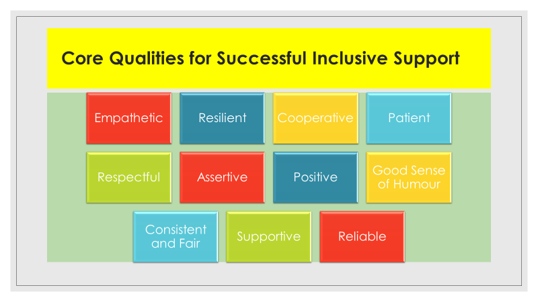

**Activity:**

**Complete a Personal Skills Profile, based on your prior learning and your Intrapersonal Skills (how well do you know yourself?)**

* [**https://www.123test.com/personality-test/**](https://www.123test.com/personality-test/)

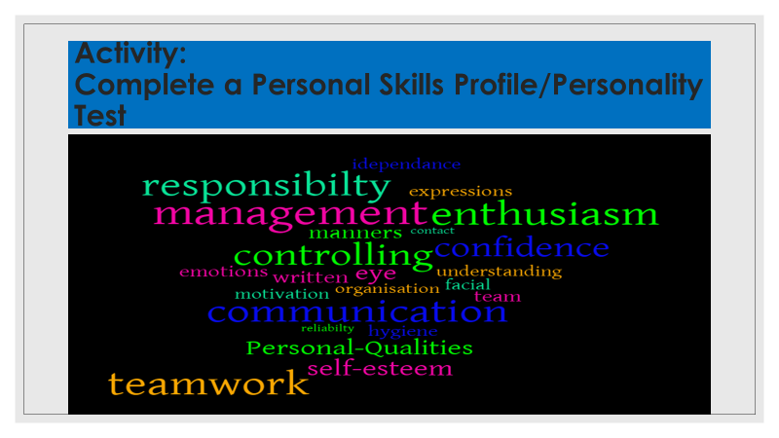

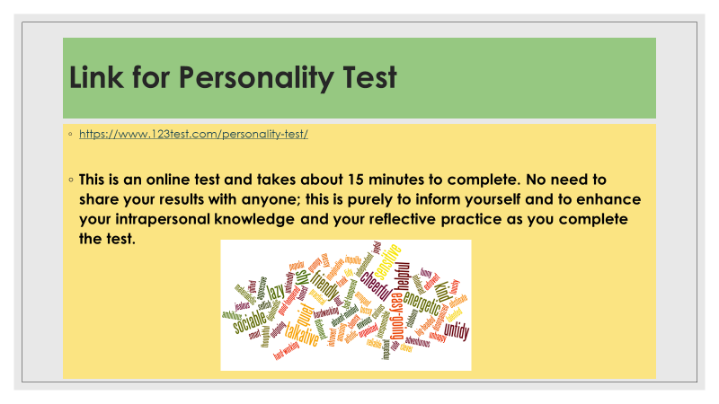

# Learning Block 2, Session 1, Module 5 – Dr.Stephen O’Neill

# (Recognising and managing stress, anxiety and trauma)

It is important to recognise that stress is part of the human experience and that stress can be both good and bad. Good stress is short-term, it can inspire and motivate you. We might feel challenged but at the same time be able to meet the challenge. Good stress can help focus your energy and enhance your performance. Bad stress on the other hand, can wear you out and can lead to anxiety, confusion, poor concentration and decreased performance. Bad stress can be short-term (acute) or long-term (chronic). Chronic stress can take a heavy toll on your body and can cause negative health effects such as headaches, insomnia, weight gain/loss, anxiety, pain and high blood pressure.

One type of stress response humans have is the fight-flight-freeze response, which is a survival instinct our ancient ancestors developed many years ago. This stress response is not a conscious decision, it is your body’s automatic natural reaction to danger and helps you react to perceived threats, like an oncoming car or barking dog. The response causes instant hormonal and physiological changes. These changes allow you to act quickly so you can protect yourself. Specifically, fight-or-flight is an active defence response where you fight or flee. Freezing is fight-or-flight on hold, where you preparing to protect yourself.

In fight or flight response, your breathing can quicken, heart beats faster, mouth goes dry and you might feel nausea or ‘butterflies’. Hands may feel cold and palms get sweaty to avoid overheating. Your pupils dilate and you get tunnel vision and you might have difficulty reading facial expressions. You might also feel dizzy and feel like fainting, but this doesn’t happen because your heart rate is up. Too much activation of the fight-flight-freeze response can result in too much bad stress. Knowing these symptoms allows us to reduce the activation of this response and brings our body back to balance.

A traumatic experience can cause an ‘exaggerated stress response’ in people. Having a better understanding of how trauma affects children and ourselves allows us to be more be sensitive to trauma and to become more trauma informed. Being more trauma informed, involves recognises the prevalence of adverse childhood experiences (ACEs) / trauma among all people. It is also understood that many of a student’s behaviours and symptoms can be as a result of traumatic experiences and that it is important to treat students with sensitivity, compassion and kindness. We also need to reduce and prevent interactions with students which might re-traumatise them. Being more trauma informed also identifies the importance of regulating ourselves before attempting to regulate the student.

When discussing trauma, we can consider the pandemic as a shared traumatic event. Research on how to recover from mass traumatic events has identified five essential elements which will aid our recovery (Hobfoll et al, 2007). These elements are safety, calmness, connectedness, self and collective efficacy and hope.

There are various strategies available to you to help apply these principles in your work which are found in the following document- ‘Supporting the Wellbeing of the School Community: Returning to School after Covid-19 School Closure – A wellbeing Toolkit for Primary Schools’ (NEPS, August 2020).

So, remember that stress and our responses to stress are a normal human experience. Keeping a balance between good stress and bad stress, keeps you regulated and is good for your mental health. It also means that you are better able to help your students keep balanced and regulated themselves.